Seabird Distribution and Abundance
Survey Protocols

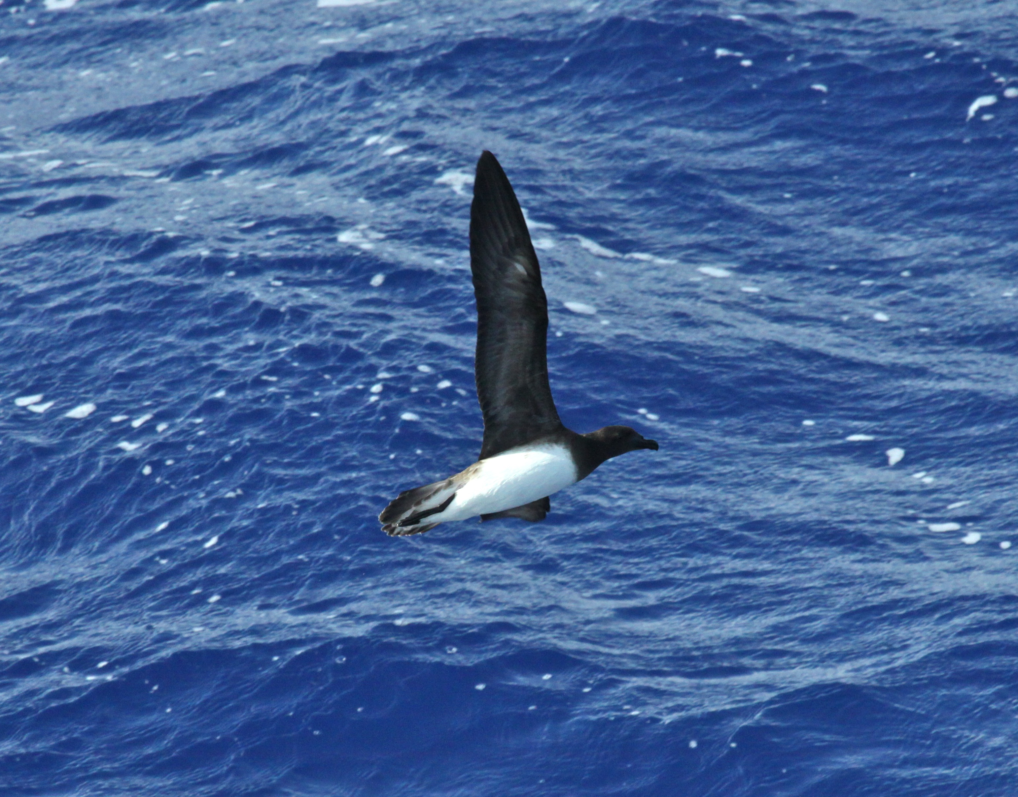

A summary of seabird protocols and data collection procedures used on NEFSC/AMAPPS surveys

Lisa Ballance, Michael Force July 2014 (revised October 2016)
NEFSC/AMAPPS Pelagic Seabird Survey Protocol

INTRODUCTION

This manual provides background information and instructions on data collection procedures in the field and data entry onto a laptop computer for pelagic seabird distribution and abundance surveys. The protocol is based on a standardized 300 meter strip transect survey widely used by agencies in North America and Europe (e.g., Anon 2011, Ballance 2011; Tasker 2004). The software used is Seebird, (version 4.3.7), a data collection program developed by Robert Holland at the Southwest Fisheries Science Center. It is designed to collect real-time data of three specific types during at-sea transects: seabird sightings, flocks and flying fish. The program is user driven by keyboard and mouse events, as well as event driven from inputs by GPS data feeds. Information on the ancillary modules, flock and flying fish, can be found in the appendices. For questions, additional copies of this manual, or a copy of the data entry and/or edit programs described here, please contact Lisa T. Ballance (lisa.ballance@noaa.gov).

GENERAL COMMENTS REGARDING STRIP TRANSECT METHODOLOGY

The primary objective of the seabird survey is to determine the distribution and abundance of seabirds in the pelagic environment. The survey strip width is 300 meters, which means you should monitor the area of ocean on one side of the ship (the side with the best viewing conditions), from bow to beam, out to 300 meters (a 90 degree quadrant). All the birds seen within this area are counted.

Observers should be aware of the assumptions associated with strip and line transects methods. The most important assumption is that ALL birds within your sampling zone (the 300 meter strip) are detected. Accordingly, you must focus your attention on this area of ocean so that you will be able to detect all birds. Most birds will be detected with the naked eye; however, use binoculars as needed to scan the perimeter of the 300 meter survey zone. This is particularly relevant with diving birds, such as alcids and loons, which frequently dive in response to approaching vessels. Therefore, you should frequently scan the count zone along the trackline in order to search for birds that could be actively avoiding the ship by diving rather than flying.

Observe from whichever side of the flying bridge is best, taking account of glare, wind etc. You should not hesitate to switch your effort to the other side of the ship if viewing conditions become better there.

Accurately estimating the 300 meter distance of your zone is another important assumption. Determining this will be accomplished using range finders based on Heinemann, 1981 (see Appendix 2). Be sure to check yourself several times a rotation or whenever you feel is necessary to help train your eye on this distance. If distance training for the marine mammal observers is included in the cruise plan, seabird observers should work with the Chief Scientist to ensure many distances at and within 300 meters are performed.

You should end the current observation period and begin a new one each time one of the following events occurs:

- A break and/or rotation in seabird observers. Make sure you are entering the correct observer code for the new observer.
- Change in visibility (scale from 1 to 5)
- Change in Beaufort scale (from 1 to 9)
- A significant course change

Only record data using the strip transect method when the ship is "on effort", that is when it is following a pre-determined track laid out for sampling the area being surveyed. During this time the mammal observers will usually be in their normal search mode.

GENERAL NOTES ON PROCEDURES

Equipment, Data Collection, General Procedures

Observations are made from a station on the flying bridge (avoid observing from the bridge because effective coverage of the survey strip is often severely compromised). Basic equipment that should be on board include:
- Data entry computer
- seabird guides
- Pencils, paper, and assorted notebooks
- Flying bridge observer station (normally a table and chair)

Seabird data will be recorded on a Toughbook computer. Data will be checked and backed up nightly onto back-up media.

Data is normally collected from 0600 to 1800 hours, or sunrise to sunset, depending on project requirements. Two seabird observers will maintain a two-hour single-observer watch rotation, or variations thereof; however, maximum watch duration shouldn’t exceed 2 hours. In extreme high density areas, two seabird observers can be on watch simultaneously, with one conducting the observations and the other recording data (be sure to record when dual effort occurs). Because the strip width is 300 meters alongside the ship as opposed to several kilometers for the marine mammal team, it will be possible to collect good bird data under conditions which preclude mammal observations. Bird observations are possible in seas up to Beaufort 7, in light fog, and in light rain. Your decision as to whether to continue observations or not will also be affected by the Chief Scientist’s decision regarding the ship’s course while the mammal observers are off effort (i.e. continuing on the trackline, or running a weather tack while waiting for conditions to improve).

Additionally, there are times when the ship will have temporary limitations that affect speed. The target speed for the seabird (and mammal) survey is 10 to 12 knots through the water. However, should the speed fall below eight knots, please be sure to comment on this, as these data may be questionable for absolute abundance estimates. If the ship’s speed falls below 6 knots, effort should be suspended.

It is possible to occasionally see an individual or group of marine mammals that are not detected by the mammal observers. Normally, do not alert the mammal observers to these sightings unless you are sure that they are very rare animals or are past the ship’s beam. However, discuss procedures to follow with the Chief Scientist prior to departure because there could be exceptions.

Generally line transect surveys for marine mammals are conducted in either passing or closing mode. Passing mode entails obtaining as much data as possible on species, group size and composition while continuing underway. Conversely, closing mode involves breaking off the trackline whenever needed to close on animals in order to confirm identification of cryptic species, and to better estimate group size and composition. When this occurs, seabird observers will temporarily need to go off effort. Seabird observations should resume once the ship has returned to the trackline and reached appropriate speed (generally this will coincide with the mammal observers also going back on effort). (NOTE: if there were birds aggregated above the marine mammals, you should wait to begin the next transect until the ship is out of this aggregation. A few minutes are generally sufficient).

All of the data collected on the ship are the official property of NMFS/NOAA/NEFSC. Should you wish to access any part of them for dispensation, analysis, or use of any kind, please discuss your intentions with the Principle Investigator/Chief Scientist.

TYPES OF DATA AND DATA CODES

There are two modes of data: "effort data" and "sighting data". Effort data contain information on the prevailing conditions when the data are recorded; sighting data contain information on seabirds and other sightings.

EFFORT DATA

CRUISE NUMBER: ("CRUISE NUMBER")

This is a 6-digit alpha-numeric string that identifies the vessel and particular cruise. For example, the summer 2014 AMAPPS cruise aboard the NOAA ship Henry B. Bigelow is HB1403. This field can be updated in the Cruise Number field in the Initialization file located at: Computer\Local Disk (C:)\Program files\Seebird\Seebird.ini.

DATE: (“GM DATE" AND “LM DATE”)

The date is recorded as a 6-digit number: the last two digits of the year, followed by two digits representing the month, followed by two digits representing the day. For example, July 30, 2014 would be entered as 140730.

The data file will contain two separate dates, one corresponding to local and the other to Greenwich date. Both will automatically be entered by the computer using its internal calendar and a link to the ship’s GPS data feed.

POSITION: (“LATITUDE” and “LONGITUDE”)

Latitude and longitude will be automatically entered by the computer using a link to the ship’s GPS. The units are decimal degrees and are recorded to the nearest 1000th of a degree. Southern latitudes and western longitudes will be recorded as negative numbers.

SEA STATE: ("BEAUFORT")

This is a 1-digit number by which you will estimate the wind velocity based on the visual appearance of the sea. We use the Beaufort scale for this (Appendix 4).

WIND SPEED:

Wind speed is estimated visually based on the condition of the sea, or obtained from the SCS. Use true wind speed, not relative, and ensure that the value entered is within the correct range for the Beaufort value entered in Sea State.

WIND DIRECTION:

Wind direction is a three digit number between 0 and 359 and is RELATIVE to the ship’s heading, the bow being zero. Wind direction is measured from the direction from which it blows (estimate to the nearest 10 degrees). For example, if the wind is on the starboard beam, then relative direction would be 90°.

SHIP'S COURSE: ("COURSE")

The ship’s course is imbedded in the ship’s GPS data feed and is automatically recorded into the computer. This course will represent the course made good, not the ship’s heading, although the difference between these two should be relatively minor. The course will be updated automatically and frequently.

OBSERVATION CONDITIONS: ("OBSERVER CONDITION")

This is a 1-digit number that combines all environmental/sighting conditions (glare, wind velocity and direction, relative measure of whitecaps, swell, etc.) into a single value. This value is used as an overall assessment of the visibility conditions during which data were collected.

Unavoidably, the assignment of an observation condition will be subjective but you should try to be consistent, at least within your own observations from day to day. Use the following as a guideline:

1 Conditions extremely bad
--Storm-Petrels, Phalaropes, and small alcids cannot reliably be detected to 100 m
--All individuals of all other species cannot reliably be detected to 200 m

2 Conditions poor
--All Storm-Petrels, Phalaropes, and small alcids visible to 100 m
--All individuals of all other species visible to 200 m

3 Conditions fair
--All Storm-Petrels, Phalaropes, and small alcids visible to 200 m
--All individuals of all other species visible to 300 m

4 Conditions good
--All individuals of all species visible out to 300 m

5 Conditions excellent
--All individuals of all species visible out to 300 m +

Remember that the first, and most important, assumption of strip transect methodology is that you are able to detect ALL of the seabirds that enter the survey strip. Although the 300 m wide strip is the default value, the Observation Condition code essentially allows one to vary the strip widths for different taxa as the visibility conditions vary. So, for example, if your data were recorded with an Observation Condition of "3", a strip width of 200 m is used to calculate density for storm-petrels, phalaropes, and small alcids, and a strip width of 300 m for all other taxa (stratified strip transect).

Accordingly, your choice of Observation Conditions for each transect is an extremely important one. The best rule of thumb to use when assigning an observation condition to a transect is to ask yourself "How far away from the ship am I able to detect ALL of the storm-petrels?"

Another important note regarding Observation Condition concerns the distance at which you record birds (see below). When using codes 4 and 5, you will want to record all species out to 300 m. However, when using code 3, you will not want to enter storm-petrels, phalaropes, and small alcids until they come within 200 m of the ship, even if you detect them farther out than this. This is because a strip width of 200 m will be used to calculate densities for these species and those entered at a distance of 300 m will not

OBSERVATION SIDE: ("OBSERVATION SIDE")

This is a 1-digit number that indicates the side of the ship used for surveying. A "1" indicates that you surveyed the area on the port side of the ship. A "2" indicates the survey took place on the starboard side of the ship.

TRACK: ("TRACK")

This is a 5-digit number that represents the track/transect that the ship is surveying. Enter this with the other effort information when beginning a transect. If not on a standardized track, or on a track that hasn’t been assigned a number, use 99999 in this field and make a comment if appropriate. Note that leading zeros are required if the value is less than 10.

OBSERVER CODE: ("OBSERVER CODE")

This is a 2-digit number that identifies the individual currently on effort and recording data on the computer. There are two fields available for dual effort. Observer codes can be modified in a text file located at: Computer\Local Disk (C:)\Program files\Seebird\ObserverCodes.txt.

21 Michael Force
33 Tom Johnson
39 Chris Vogel
40 Jeff Gleason
41 Marie-Caroline Martin
42 Michael Sylvia
43 Nicholas Metheny
44 Tim White
99 Other

SIGHTING DATA

EVENT CODE: ("EVENT CODE")

An event code is used to indicate the reason for entering the current line of data. There are 7 codes:

0 - Automatic Time/Position update
This code will automatically be entered by the computer approximately every 5 minutes (interval modifiable) and a time and position stamp will follow.

1 - Begin Transect
Use this code to indicate the beginning of an on-effort transect. You will need to begin a new transect when seastate and observation conditions change, when you change observers, or when you change sides of ship. The data entry program will not allow you to record sightings or change effort data until you enter this “Begin Effort” line.

2 - On Effort Sighting
Use this code to indicate a sighting of any type while you are on effort. A sighting will include birds, predatory fish, molas, turtles, marine mammals, boats, fixed fishing gear, etc.

3 - End Transect
Use this code to indicate the end of an on-effort transect. The most common reasons for ending the effort period will be a course change when the ship starts a new survey track, a change of observers, a change in environmental conditions, deviation from the track to pursue a marine mammal sighting, or the end of the day. The data entry program will not allow you to resume effort, or exit the program, until the current transect has been closed.

4 - Cumulative Total
You may encounter a situation when the bird abundance is so high that it becomes impossible to count and enter individual birds in real time. In these situations, it will be necessary to count birds in blocks (as groups of 10's for example) and enter these numbers periodically, at regular intervals (every 5 minutes for example).

Should such a situation arise, the critical data are species identification and count for each time period. You “may” record accurate data for remaining fields (such as shearwaters streaming across the trackline, e.g., flying directionally), but if time does not allow for this, use distance code 3 (you should not count any birds if they are farther than 300 meters from the ship), behavior code 6 (for "other", and note in the comments field that for this situation you are using this code to indicate that no data on behavior were recorded), and codes for “unknown” for plumage, association, age, and sex (4, 3, 1, and 1, respectively). Use code 9 for flight height to indicate that no flight height data were recorded.

Because this project will generally be designed to survey birds in oceanic areas (i.e. where bird densities are relatively low) you should rarely need to use this code.

5 - Off-Effort Sighting

As is the case for an on-effort sighting, you should use this code to indicate a sighting of interest such as an unusual bird, bird flocks, mammals, fish, and turtles. The difference is that an event code of "5" signifies that you were not on regular transect effort when the sighting was made. In general, there is little practical use for off-effort sightings. There are only a few situations in which you will need to record them:

a) when you see a "rare" bird (in other words, one not yet recorded during that day's effort)

b) when you see any other animal or object that is unusual

c) when the ship’s speed falls below 6 knots and you wish to collect sightings data for distributional purposes

In general, an off-effort sighting allows the recording of data for "significant" events, even though you are not on effort. All off-effort sightings, by definition, will occur between the end of one transect and the beginning of another one.

Note that if you are on effort and wish to record birds, or any other unusual events that occur outside the 300 m strip transect, the proper event code is a 2, not a 5, and the distance code is a 4 (see below).

6 – Comment

This code is used to enter a comment that is not directly associated with any of the previous events. You can enter a text comment at any time simply by using this event code.

TIME: (“GMT" and “LMT”)

Time corresponds to the time at which the event recorded in the previous field occurred. The time will be recorded as a 6-digit number: 2 digits representing the hour, 2 digits representing the minute, and two digits representing the seconds.

Time will be automatically entered by the program using the computer clock. This clock will read according to local time, although each line in the data file will contain both LMT (Local Mean Time) and Greenwich Mean Time (GMT). All times will be based on the 24-hour system (i.e. 3:00 p.m. = 15:00).

Time will be automatically synchronized to the ship’s GPS time stamp every time you start the data entry program. Upon starting, the program will prompt you for the local hour. When you enter this, the program will automatically synchronize this hour with the minutes and seconds read from the ship’s GPS unit to re-set the computer’s internal clock. The program will also automatically calculate the GMT offset.

SPECIES CODE: ("SPECIES CODE")

This is a 4-letter code that represents the identity of the species you are recording.

You will memorize these codes over time. For seabirds, the general rule of thumb is that the first two letters of the code represent the common name at the species level while the second two letters represent the common name of the taxon at the genus level (i.e. "BO" for boobies, "GU" for gulls), thus "BRBO" for Brown Booby, "BOGU" for Bonaparte’s Gull). However, note that there are many exceptions to this, often concerning trinomials and conflicts, so have the species code list easily accessible until you have learned them. Moreover, Seebird will not accept an invalid species code and you will not be able to write the record to disk until a valid code is in place. A PDF of the species codes can be conveniently placed on the desktop for quick reference.

The external file Seebird uses to look up species codes is located at: Computer\Local Disk (C:)\Program files\Seebird\SpeciesCodes.txt. You can add to this list but do not modify existing codes and ensure your new code isn’t already in use. A recommended standardized 4-letter code list for North American birds can be found at http://www.birdpop.org/alphacodes.htm.

There will be occasions when you will see more than one species simultaneously. In this case you will need to record the code for the first species along with the remaining sighting data on one line. Then, using the same time as was recorded for this line of data (see below), record the code for the second species, along with the remaining sighting data, on the next line.

SPECIES NUMBER: ("SPECIES NUMBER")

This number represents the number of individuals for the species you are recording and should be entered for all sightings. There will be certain cases when you will not know the number of individuals, or be able to estimate that number. In these instances, you should enter a “9999" in this field, which will indicate that the species was present, but no number information is available.

DISTANCE: ("DISTANCE")

This single digit number represents the distance from the ship to the bird when you first saw it (or when it first enters your survey strip). Use the following codes:

1 - 0 - 100 m from the ship
2 - 100 - 200 m " " "
3 - 200 - 300 m " " "
4 - outside of this area

Note that a code of "4" applies to a bird closer than 300 m to the ship, when it is on the opposite side from your survey side.

Distance code 4 is included primarily so you can record rare birds, even when they do not enter our 300 m strip. At times, this rare bird information will come from the few mammal observers who are experienced birders and who detect these species with the high-powered binoculars. Although it may be tempting, be careful not to spend too much time scanning for birds in zone 4 – because you may miss birds in the 300 m strip. (Remember, these are “On Effort” sightings if YOU are currently on effort.)

ASSOCIATION: ("ASSOCIATION")

This single digit number represents the kind of association (if any) between individuals sighted at the same time. Use the following codes:

1 - Individual(s) not associated with others at the time the sighting is recorded. This code will be used for a solitary bird.

2 - Individual(s) associated with other individuals at the same time. This code will be used for birds flying together, sitting in a group on the water, or any other aggregation in which the species involved are "associating" (individuals responding to the same stimulus or to each other). Use this code if the bird(s) is (are) associating with marine mammals, surface shoaling fish, fishing gear/vessels, flotsam (biological or anthropogenic) or oceanographic features. Use the comment field to add additional information as required.

3 - Association unknown

BEHAVIOR: ("BEHAVIOR")

This single digit number represents the behavior of the individual(s) at the time of the sighting. Use the following codes:

Code | Name | Description
1 | SITTING | For birds sitting on the water or standing on flotsam or turtles; one can use an additional line to identify what the bird was standing on (e.g., FLOT or turtle). Use the same time for both lines of data (associated).
3 | FOLLOWING | For birds following and/or attracted to the ship (see below).
4 | FEEDING | Bird seen to take food. Make a note of the prey item if possible.
5 | PIRACY | A specialized feeding behavior most often seen in skuas, jaegers and frigatebirds. Use for both the pirate and the victim and ensure the same time is used for the entire event (associated).
6 | OTHER | Be sure to explain the meaning of this code in the comments field each time you use it.
7 | UNKNOWN | One can use a comment for further clarification.
8 | DIRECTIONAL FLIGHT | The bird is flying directionally (see below).
9 | NON-DIRECTIONAL FLIGHT | No apparent flight direction (see below).
10 | MILLING | Generally used for birds circling over an object of interest, but not proceeding in any constant direction; often considered a type of foraging behaviour.
11 | PATTERING | Foot-pattering into the wind with wings held open, commonly used for foraging/feeding storm-petrels.
12 | PORPOISING | Penguin swimming behavior (rarely seen in the Northern Hemisphere).
13 | DIVING | Surface dive (e.g., alcids, loons or shearwaters, some ducks), as opposed to a plunge dive from height (e.g., gannets, tropicbirds).

It may happen that you will see several birds at the same time engaged in more than one type of behavior. In this case you should record the code for the species, the number of individuals engaged in the first category of behavior, and the code for this behavior on one line. Then, using the same time as the previous sighting, record the species code, the number of individuals engaged in the second category of behavior, and the code for this behavior on the next line.

Ship Following

Ship following (here analogous to “ship attracted”) is a special type of behavior that is important to note. Birds of certain taxa almost always divert their course to approach, and sometimes, to follow a ship every time they see one. Such birds are called "ship followers." These are usually, but not always, scavenging species. Classic ship following groups are albatrosses, some petrels and shearwaters, boobies (especially juvenile Red-footed and Brown), skuas (ship attracted), gulls and tropicbirds. It is important to note ship following because these birds must be treated differently in density calculations. Because a ship follower will come over to the boat, you will record an artificially high number of these types of birds in the 300 m strip. If this number was to be used in density calculations, the density value would be inflated. Typically, some sort of correction factor is applied to ship followers to account for this artificially high number.

A ship follower is fairly easy to identify, as it will usually circle at least several times before it leaves. Some birds will stay with the ship for several hours, some all day long. It is important to count these individuals only ONCE -- and this is not always easy. Noticing some individual plumage mark or pattern is one way in which you can learn to recognize a particular bird so that it is not counted twice.

Flight Behavior

We record flight behavior, among other reasons, in order to be able to calculate abundance. For this purpose, it is important to distinguish between directional and non- directional flight. It is usually easy to make this distinction. A few notes will help:

1) A behavior code indicating directional flight means that the bird was flying in one direction.

2) Many shearwaters and petrels use the wind as an energy source while in flight. Their flight behavior consists of a series of banking movements up and down, left and right of their overall flight direction. Even though they progress in a zigzag direction, this is considered directional flight because their “course made good” is in a single direction.

FLIGHT DIRECTION: ("FLIGHT DIRECTION")

This is a 3-digit number that represents the flight direction of the bird relative to the ship's heading. Record the direction in which the bird is flying in degrees. So, for example, if the bird is flying in the same direction as the ship is traveling, flight direction is 000 (or just 0). If the bird is flying perpendicular to the ship, flight direction is 90 if the bird is flying to the right, 270 if to the left. And if the bird is flying in the opposite direction as the ship's course, flight direction is 180.

You will only need to record flight information if the Behavior code is “8,” that is, if the bird is flying directionally. Otherwise, the computer will automatically enter “999" which is the code indicating that flight direction information is not applicable to this sighting.

FLIGHT HEIGHT: ("FLIGHT HEIGHT")

This is a single digit representing the average height above water at which the bird is flying. If the behavior code is “1” (sitting) then the computer will automatically enter “9" which is the code indicating that flight height information is not applicable to this sighting. Use the following codes:
1--0-2 meters
2--2-10 meters
3--10-25 meters
4--25-50 meters
5--50-100 meters
6--100-200 meters
7-->200 meters
9--flight height unknown and/or not applicable

ANGLE: ("ANGLE")

The angle at which the bird was observed, used to calculate perpendicular distance from the trackline. Use “999” for when no angle information was collected and/or wasn’t applicable to the sighting.

AGE: ("AGE")

This single digit number represents the estimated age class of the sighted individual. Use the following codes:
1 -- age unknown
2 – not full adult (includes juvenile, immature, and sub-adult)
3 – full adult

Should you see birds at the same time which comprise two or three of these age categories, enter the data for each age class on a separate line and record the same time (that of the initial sighting) for each line. The comment field is available if you wish to enter additional information.

SEX: ("SEX")

This single digit number represents the sex of the sighted individual. Use the following codes:
1 -- sex unknown
2 -- female
3 -- male

Should you see birds at the same time which comprise 2 or 3 of these sex categories, enter the data for each sex on a separate line and record the same time (that of the initial sighting) for each line.

PLUMAGE: ("PLUMAGE")

Use this 4-digit code to give a rough idea of the plumage condition or state. Use the following codes:
1--breeding
2--non-breeding
3--molting (if time permits, add additional molt information in “Comments”).
4--unknown and/or not applicable

COMMENTS: ("COMMENTS")

This is a 1 digit number that indicates whether further comments on the sighting have been recorded. Use the following codes:

1 -- No Comment

You should enter this value when you have no comment regarding the current line of data.

2 -- Comment

Use this code any time you observe an event which deserves some written comments. For example, if you see a bird which is not expected to be in the project area, you might want to record details specifying how you arrived at your species identification. If you see a bird involved in an unusual behavior, you may want to record details of this behavior. These comments can be entered into the text field. Additionally, if you need to draw, a green record book will be provided for this purpose. You should not need to use this book often, if ever. But if you do enter information into the green book, be sure to record the date and time (specify whether this is local or Greenwich date/time) corresponding to the data record so we can link the information correctly.

GMT OFFSET:

This is a 1-digit number that indicates the difference between LMT and GMT. The number is always positive and will be automatically entered by the computer when you start the program, enter the local hour, and press the “Get Time Sync” button.

TEXT: (“TEXT”)

Use this field to type specific comments for any record. The computer will only allow you to type comments here if you have entered a “2" in the previous field (“Comments”). However, if you do type text into this field, the computer will automatically change the Comment Code to “2” if you haven’t already. Otherwise, the computer will automatically skip over this field and leave it blank.

Rare Birds

Not infrequently, the mammal observers (which use 25 power binoculars) will see one or more species which do not fly into the 300 m survey strip. In these cases, it is desirable to have them in the database to show that they were present in the area for a particular day. The best way to accomplish this is to ask the mammal observers (only the accomplished birders) to let you know when they see a bird not yet recorded. When this happens, you should enter a line of data that records that species at a particular time in zone 4 (outside of the survey strip).

Although it is tempting, be careful not to spend so much time scanning for rare birds outside the 300 m strip that you run the risk of missing those within the strip.

Remember that these rare bird sightings are “On Effort” sightings, if YOU are on effort, and “Off Effort” sightings if you are off effort.

SEABIRD STRIP TRANSECT DATA

STARTING THE SEEBIRD DATA ENTRY PROGRAM AND GENERAL NOTES

At the beginning of the day, you will need to start the computer, connect the computer’s serial port to the ship’s Ethernet data port on the flying bridge, and open the Seebird program (in that order). To open Seebird, simply double click on the Seebird icon. The program is located in the “Seebird” folder on the root level of C: drive. You can also access the program by double clicking on the Seebird.exe file (putting a shortcut to the .exe file on the desktop will be useful). The program will automatically start and you will be prompted to enter the “Local Mean Hour” (use 24-hour time). Once entered, click the “Get Time” button. This will synchronize the computer’s clock (minutes and seconds) with the ship’s GPS time. The program will also automatically calculate the GMT offset by comparing the local hour with the Greenwich hour (from the GPS) and fill in the “Offset” box on the initial screen. The only time you should manually fill in this “Offset” box is when the ship’s GPS is not functioning; in practice, this should rarely happen, if ever. (The offset value should always be positive.)

The Seebird window consists of five horizontal panes (Figure 1). The topmost pane displays effort data (date and time, GPS values, etc), cruise number, and a box indicating in bold letters whether one is ON or OFF effort.

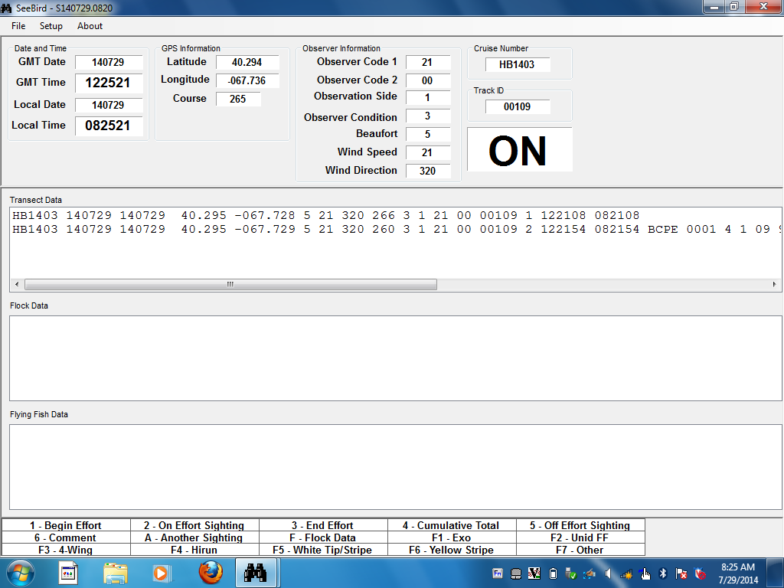

Figure 1. Example of the on effort Seebird window.

The next three panes, labeled “Transect Data”, “Flock Data” and “Flying Fish Data”, display respective sighting data. These three panes reveal the most recently entered lines of data, with previously entered records scrolling up and off the screen. You can always look at any record simply by using the scroll bar on the right side of the window. Note that Flock Data and Flying Fish Data may not be part of the cruise objectives and will not be used if that’s the case (see Appendix 1).

The final, bottommost pane displays a handy list of event codes, corresponding flyingfish function keys and several other codes you will be using during the course of the day; it will always remain visible for quick reference.

A second window opens in the background when Seebird opens (Figure 2). Here, Seebird keeps a list of all species codes used that day. It is automatically populated with species codes as they are entered. It can be a convenient method of determining if a particular species has been seen that day. Be aware that the list is not carried over if Seebird is closed for any reason (e.g., a weather shutdown and then restarted the same day) and will be blank.

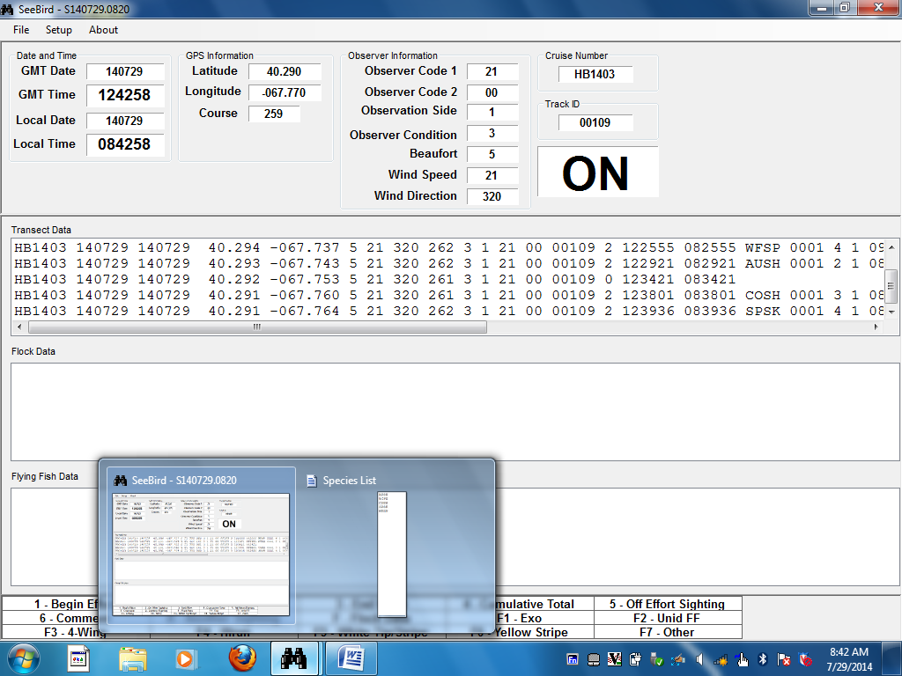

Figure 2. Additional windows available in Seebird

Data entry will be done through data input dialogue boxes. These will appear as overlays on top of the data records when each data entry event code is entered. As the cursor moves through the various data input fields during data entry, a list of data codes and their definitions for the field in which the cursor is currently located will appear on the right side of the dialogue box. Note that not all fields have these “cheat sheets”. This is explained in greater detail below. Figure 3 provides an example of an open On Effort Seabird sighting dialogue box, completed and ready to be recorded to disk

ENTERING DATA

Although there are two basic types of data, Effort and Sighting, they will be recorded on the same line. When you begin or end a transect, only those fields comprising Effort information will be recorded; when you make a sighting, both Effort and Sighting data fields will be recorded. A complete line of data will thus contain part or all of the following variables, in the following order:

CRUISE NUMBER, GMT DATE, LOCAL DATE, LATITUDE, LONGITUDE, BEAUFORT, WIND SPEED, WIND DIRECTION, COURSE, OBSERVATION CONDITIONS, OBSERVATION SIDE, OBSERVER CODE 1, OBSERVER CODE 2, TRACK ID, EVENT CODE, GMT, LMT, SPECIES CODE, SPECIES NUMBER, DISTANCE, ASSOCIATION, BEHAVIOR, FLIGHT DIRECTION, FLIGHT HEIGHT, ANGLE, AGE, SEX, PLUMAGE, COMMENTS, GMT OFFSET, and TEXT

You must manually type in some effort and all sighting data for the first record in the data file. After that, the program will automatically display the values from the previous record in the fields for the current record (with a few exceptions). Accordingly, you will always have three options for data entry.

First, you can manually type in data for each record by typing over the displayed values and pressing the Tab key or Down Arrow key to advance the cursor from one field to the next. Additionally, when the cursor enters a field, the field becomes highlighted and you can simply type over the existing value without having to backspace.

Second, IF the value that is automatically displayed for a field (that value entered for the previous record) matches the value you would like to enter for the current record, simply press the Tab key (or Down Arrow key) and this value will automatically be recorded into the present variable.

Third, if ALL of the data for a particular line are the same as the previous record, pressing the Escape key will record this line of data into the file.

Navigating within the data entry dialogue boxes is easily accomplished using the Down Arrow or Up Arrow keys; or the Tab key or the Shift-Tab key combination depending on whether you wish to move down to the next data field or move backwards (up) to the previous field, respectively. If you wish, one can use a mouse (if available) or the trackpad.

For every data record, the program automatically enters date, time, and position using values from the computer calendar and clock, and the ship’s GPS feed.

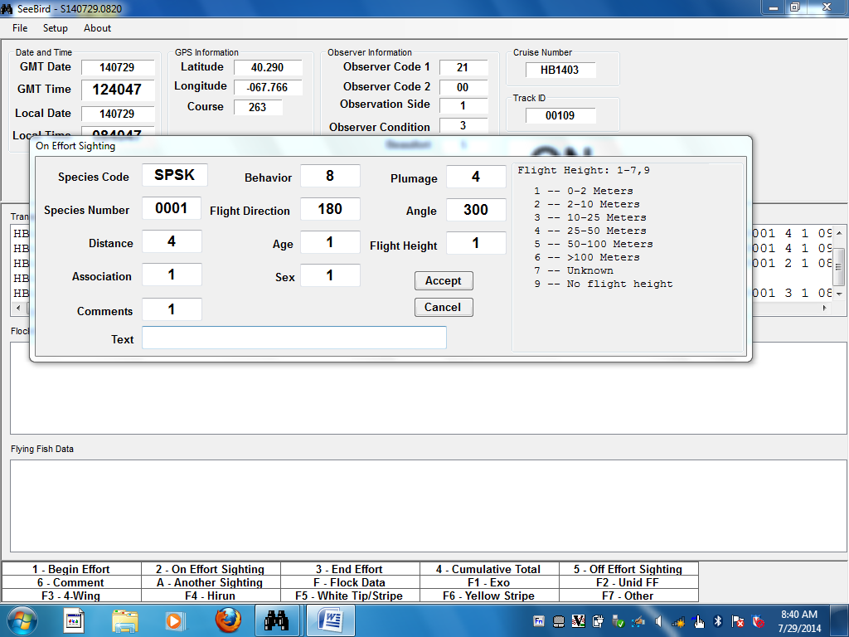

Figure 3. The On Effort Sighting dialogue box (active cursor in the “flight height field).

EVENT CODES

Not all records will need both Effort and Sighting data. When you begin and end a transect, only Effort data are needed; for any sighting (on- or off-effort, as well as a cumulative total), you will need both Effort and Sighting data. Accordingly, the program behaves slightly differently, depending upon the Event Code that you use.

To begin a transect, enter 1 for Event Code and the Begin Effort dialogue box will appear allowing you to enter data for the relevant Effort fields (Observer Code, Observation Side, Observation Conditions, Beaufort, Track ID and Comments). Once these data are entered, click on the Accept button or press the Escape key to record these data. The program will automatically record this line of data in the file and you will see it appear in the data field in the uppermost pane. You are now ready to enter the next record.

To enter a sighting, enter Event Code 2. You will need both Effort and Sighting data. The Effort data is automatically entered by the computer, but should match those entered when you began the transect (with the exceptions of position, course, and time). If any of these fields do not represent the current conditions, you must end the transect, and begin a new one with the updated information. Entering an Event Code 2 will automatically open the On Effort Sighting dialogue box. The cursor will appear in the Species Code field and you can begin entering data for that particular sighting. Press the Tab key or Down Arrow key to move from one field to the next as you continue to input the remaining Sighting data for that record. The last field is that for Comments (or Text, if you have entered a comment). Once finished, press Escape (or click the Accept button or press Enter/Return if the focus is on the Accept button) and this record will be recorded into the data and appear in the uppermost data pane below the previously entered record. The program automatically auto-validates data upon entry, so if the On Effort Sighting dialogue box will not close when you hit Escape or Accept, then you either have an incorrect species code and/or an unacceptable value in one of the data fields. Once the correction is made, then the box will close and the data written to the file. This greatly reduces errors and makes the nightly edit much easier.

Each time you enter an Event Code 2, the values from the previous record will automatically appear. You can confirm them as correct by pressing the Tab key, or overwrite them with the keyboard. While this greatly speeds up data entry, ensure that no incorrect and/or irrelevant data has been carried down from the previous record. Text comments from the previous line, if there were any, will also be carried down. Navigating to the text field and hitting the Delete key will clear the field.

To end a transect, use Event Code 3; the End Effort dialogue box will automatically open. If you have no comments to add, press the Escape key (or tab to move the focus to the Accept button and press Return, or click on the Accept button) and this line of data will be recorded into the file. The program will not accept any further on effort sighting data until a new transect is started.

If you use the Event Code for cumulative total (code 4) or for an off-effort sighting (code 5), the program will behave as described for Event Code 2, above.

RECORDING DATA ON MORE THAN ONE OCCASION DURING THE SAME DAY

Each time the program opens, a new ASCII data file is created. These files are named with the format “SYYMMDD.HHMM” where “S” indicates it is strip transect data (as opposed to flock data for instance), “YY” is the last two digits of the current year, “MM” two digits corresponding to the month, “DD” two digits corresponding to the day (from the computer calendar), “HH” and “MM”, the digits corresponding to the local hour (in 24-hour time) and minute at which you began the program (from the computer clock). Thus, if you close the program and re-start it later the same day (such as during a weather interruption), the data will automatically be recorded into separate files. You will combine and re-name the newly edited file(s) at the end of the day conforming to the file naming conventions used on the survey.

RECORDING A SINGLE TIME FOR MORE THAN ONE LINE OF DATA

In a number of instances you will require several lines of data to enter the information representing a single sighting. This will occur when you have seen birds of more than one species, age class, or sex at the same time; when some individuals are performing one behavior and some are performing another; or when you sight a number of individuals at the same time in more than one distance zone from the ship. In all of these instances, you will want to record a single time for each of the lines representing the sighting instead of recording the current time.

By default, the computer will display the current GMT and LMT in both Time data fields. Each time you type in an Event Code followed by the Tab key, the current times are automatically recorded for that record. If you wish to use the times recorded for the previous record, do not type in a numeric value for Event Code. Instead, enter “A”. This will open an On Effort Sighting dialogue box containing values identical to the previous record, including time and position values. Simply modify the necessary data fields for the new sighting. Repeat this for each record for which you need an identical time. Again, this greatly expedites data entry, particularly if you enter a high density area. Remember that you can have birds occurring at the same time that are not associated (different distances from the ship for example); the association code will then be “1”, not “2”.

A simple way to remember this rule is a) when you wish to use the current time, you must manually type in the Event Code value; b) when you wish to use the time recorded for the previous record, enter the letter “A” (think “another”).

CORRECTING MISTAKES

There may be times when you discover that you have entered an incorrect value. It is easy to correct these mistakes.

If the data record has not yet been written to disk (that is, if the Data Entry dialogue box is still open), simply overwrite the existing value with the correct one.

If the Data Entry dialogue box is closed and the data record is displayed in the uppermost data pane in the middle of the screen), double-click anywhere on the line of data containing the mistake. This will open the Edit Dialogue box where you can review all of the Effort and Sighting fields and relevant data for that record. User-alterable fields are highlighted in yellow. Type over the value(s) you wish to change, and press Escape (or click Accept) when done. The corrected line of data will be recorded into the file and displayed in the data pane.

You may only change values for the “Sighting” data. If you notice an incorrect value for an “Effort” field, you will have to end your transect and begin a new one with the updated Effort information AND correct the mistakes in the Effort fields during the nightly edit (see below).

BE CAREFUL WHEN TYPING OVER EXISTING DATA. Once the value has been lost, it cannot be regained.

DUPLICATION OF DATA FROM PREVIOUS LINES INTO THE CURRENT LINE

As already explained, the program has a default function that automatically displays data from the previous record in the fields for the current record. Many times you will want to enter the same value for a particular field into subsequent lines of data. For example, in many cases you will be unable to determine the age or sex of the birds you have seen. Therefore, most of the values for AGE and SEX will be "1" (unknown). By automatically displaying previous values, you may accept these previous values by pressing Tab (to move to the next field), and then simply press Escape once all fields for the current line of data are correct (rather than having to manually enter values for all fields).

THE GREEN COMMENT BOOKS

Green books should be available to make any notes necessary for the evening data edit (see below), or to make comments on anything that the data entry program will not allow you to enter directly. In practice, you should not need these for anything but daily reminders to yourself, since the data entry program lets you enter comments directly on to the computer. However, don’t hesitate to make as many notes/comments you feel you need to make the nightly edit that much easier. If the comment refers to a particular sighting (and it usually does!), be sure to note the relevant time in the green book so the proper record can be easily found in the data file.

THE END OF THE DAY

CHECK LIST FOR THE END OF EACH DAY

1. Close the Seebird program, secure other equipment, and bring down the computer and any water-sensitive items.

2. Working from the seabird computer, locate the daily observation file(s), located in Computer\Local Disk (C:)\Program Files\Seebird.

3 Move the original, unedited file(s) from its original location in Computer\Local Disk (C:)\Program Files\Seebird into a clearly marked folder at the root level of the C: drive and open it using Excel’s Text Import Wizard. If you wish, you can work from a copy of the file and saving it as another file in the Excel format. Either way, ensure you keep an original unedited version of the raw data file. Appendix 5 provides an example of the data output file after being exported into Excel.

4. Check and edit the day’s seabird strip transect data. Using Excel (or another data editor), take a look at the data and make any changes that you noted in the green book. It would be useful to label the respective columns. When you make a correction from the green book into the data, please put a clearly visible check mark next to the comment in the green book. Furthermore, check to see that wind speed corresponds to the correct Beaufort value; that times make sense; and for any other irregularities such as incorrectly applied association codes and incorrect species number. Save the edited data file with a different name than that of the raw file; use the format “xx(x)YYMMDD.xlsx” (where “xx” is the two or three letter abbreviation for the ship) and store the clean file in an unambiguously named folder. Note that if more than one file exists for a particular day, you will need to combine them into a single file before beginning the edit process.

5. Copy the clean, newly edited file onto some backup media such as a thumb drive or an external hard drive.

TROUBLESHOOTING

GENERAL COMMENTS

Seebird is a mature and robust data acquisition program modified through many years of pelagic seabird surveys; it requires essentially no maintenance from the user. The program is fairly rigid in data input so to minimize data errors. The rigidity of the program can be strengthened through the use of external data files that the program can use to check new data entered. The external data files that are user-modifiable have already been discussed.

The current version of Seebird requires a serial feed on the COM1 communications port. An Ethernet to serial cable (Figure 4) may be required to enable the connection. Once the necessary hardware is in place, it is simply a matter of opening Seebird and verifying that communication is established with the ship’s GPS feed. If the time sync feature fails, and/or Effort Data fields requiring input from the ship’s GPS are blank (e.g., latitude and longitude), then there is an issue with the incoming data stream.

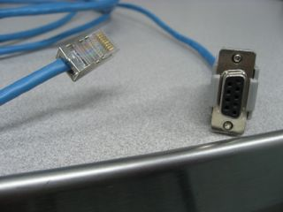
Figure 4. Serial to Ethernet cable

INITIALIZATION WINDOW

All instances of Seebird failing to initialize can be attributed to problems with the data feed from the ship’s GPS. The essential tool needed to diagnose serial device communication issues is the Windows utility Hyperterminal. Although it is part of the Windows XP operating system, it is NOT pre-installed on newer versions of Windows such as Vista and Windows 7. Alternatives do exist, but Hyperterminal is the preferred tool to troubleshoot serial devices easily and efficiently. In most situations, Seebird is “plug and play”; however, if problems do arise, Hyperterminal is your go-to tool. Make sure it is on the laptop before leaving port.

Figure 5 provides an example of Seebird’s Initialization window. This is accessed in the Seebird menu under “Setup”. Alternatively, these values can also be accessed at Computer\Local Disk (C:)\Program files\Seebird\Seebird.ini. When making changes to this and other external look-up files, be sure to save them in their original format and DO NOT change their locations.

Incorrect readings on either the GPS Location string ($GPGLL) or the GPS speed string ($GPRMC) will result in, for example, obvious errors in the Speed Column or Ship Heading (e.g., values being shifted left or right in the output). An unusual communications malfunction occurred during a recent AMAPPS cruise. The diagnosis returned using Hyperterminal was that the two required communication strings, $GPGLL and $GPRMC, were being separated at source and arriving on two different serial ports, COM1 and COM3, respectively (claimed by some to be impossible). Not only was there no functioning time sync, the ship’s speed and course values were incorrect. Only when the incoming data stream was viewed with Hyperterminal was this anomalous situation apparent. In this and other situations where the feed is the issue, enlist the help of the ship’s Electronics Technician, who has to adjust settings in one of the ship’s GPS broadcast boxes located below deck, often in the bridge. In this case, a quick and simple modification by the ET solved the problem.

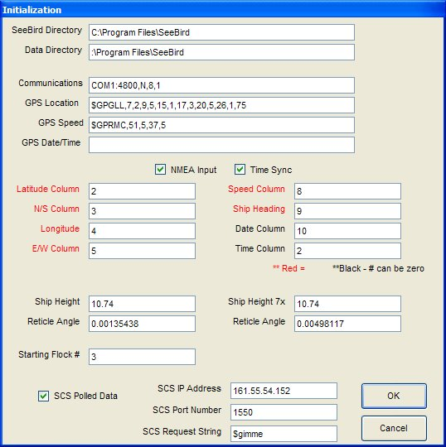
Figure 5. An example of Seebird’s Initialization window

The Initialization window contains all of the necessary setup information that Seebird relies upon for normal operation. The following is a description for each item.

Seebird Directory – The directory where Seebird is installed. Typically the directory will be C:\Program Files\Seebird

Data Directory – The directory where the data files will be saved. The default is the Seebird Directory.

Communications – Serial port where the program gets its GPS input. The format is as follows in this example:
COM1:4800,N,8,1
1 2 3 4 5
1) Comm port
2) Baud rate of incoming data
3) Parity bit (N=none, E=even, O=odd)
4) Data bits (8 if parity is N, 7 otherwise)
5) Stop bits

GPS Location – Contains the search string for the GPS line with latitude and longitude, plus the format for the line. The format is as follows in this example:

$GPGLL,7,2,9,5,15,1,17,3,20,5,26,1,75
1 2 3 4 5 6 7 8 9 10 11 12 13 14

1) Search string. Each line from the GPS has a unique identifier.
2) Number of characters after the start of the search string where the latitude degrees begins.
3) Number of characters long for the latitude degrees.
4) Number of characters after the start of the search string where the latitude minutes beings.
5) Number of characters long for the latitude minutes.
6) Number of characters after the start of the search string where the north/south indicator begins.
7) Number of characters long for the latitude north/south indicator.
8) Number of characters after the start of the search string where the longitude degrees begins.
9) Number of characters long for the longitude degrees.
10) Number of characters after the start of the search string where the longitude minutes begins.
11) Number of characters long for the longitude minutes.
12) Number of characters after the start of the search string where the east/west indicator begins.
13) Number of characters long for the longitude east/west indicator.
14) Number of characters to read in before the program will begin the parsing of the incoming GPS data.
(format numbers 2 through 14 will only be necessary if NMEA Input check box is NOT checked)

GPS Speed – Contains the search string for the GPS line with the ship’s speed and heading information, plus the format for the line. The format is as follows in this example:

$GPRMC,51,5,37,5
1 2 3 4 5

1) Search string. Each line from the GPS has a unique identifier.
2) Number of characters after the start of the search string where the ship’s course begins.
3) Number of characters long for the ship’s course.
4) Number of characters after the start of the search string where the ship’s speed begins.
5) Number of characters long for the ship’s speed.

(format numbers 2 through 5 will only be necessary if NMEA Input check box is NOT checked)

GPS Date/Time – Currently not used.

NMEA Input (check box) – If this box is checked, then the program will get its GPS column information from the column boxes shown below the check box. If the box is not checked, then the program will get its GPS format information from the GPS Location and GPS Speed lines.

Time Sync (check box) – If this box is checked, the Sync window will appear when the program starts and will synchronize the system date/time with the date/time from the incoming GPS data feed. This ensures the time returned by Seebird matches that of the ship’s SCS.

Latitude Column – The column in the GPS Location search string where the latitude resides. Each column is separated by a comma in the GPS data feed. The GPS Location search string will always be column 1. This box will only be used if the NMEA Input check box is checked.

N/S Column – The column in the GPS Location search string where the latitude north/south indicator resides. This box will only be used if the NMEA Input check box is checked.

Longitude Column – The column in the GPS Location search string where the longitude resides. This box will only be used if the NMEA Input check box is checked.

E/W Column – The column in the GPS Location search string where the longitude east/west indicator resides. This box will only be used if the NMEA Input check box is checked.

Speed Column – The column in the GPS Speed search string where the ship’s speed resides. This box will only be used if the NMEA Input check box is checked.

Ship Heading Column – The column in the GPS Speed search string where the ship’s heading resides. This box will only be used if the NMEA Input check box is checked.

Date Column – The column in the GPS Speed search string where the GPS date field resides. This box will only be used if the Time Sync check box is checked.

Time Column – The column in the GPS Speed search string where the GPS time field resides. This box will only be used if the Time Sync check box is checked.

Ship Height 25x – Height in meters above sea level where the 25 power (big-eye) binoculars are mounted.

Reticle Angle 25x – Calculated angle for the reticle marks in the 25 power (big-eye) binoculars based on the Ship Height 25x value.

Ship Height 7x – Height in meters above sea level where the 7 power (hand-held) binoculars are used.

Reticle Angle 7x – Calculated angle for the reticle marks in the 7 power (hand-held) binoculars based on the Ship Height 7x value.

Starting Flock # - The value to start with for flock sighting numbers. As the program is used and flocks are entered, the program will start with the flock number last used. This box is used to reset the starting value.

SCS Polled Data (check box) – If this box is checked, Seebird will request oceanographic data from the SCS computer to be merged with a seabird sighting to create a combined (merged) oceanographic/seabird sighting file. The SCS computer needs to have “Send SCS Message” set up to send the requested oceanographic data. Available only with version 8.0+ of Seebird.

SCS IP Address – The IP address of the SCS computer on the ship’s network. Available only with version 8.0+ of Seebird.

SCS Port Number – The port number on the SCS computer used to receive requests and issue returned data. Available only with version 8.0+ of Seebird.

SCS Request String – The polled request string used to activate the “Send SCS message” on the SCS computer. This is what the SCS computer looks for to send back the oceanographic data. Available only with version 8.0+ of Seebird.

APPENDICES
Appendix 1 Additional Data Types

SEABIRD FEEDING FLOCKS

FLOCK SIGHTING DATA

Strip transect survey data for feeding flocks and/or flocks associated with marine mammals can be entered using the Flock module built into Seebird. Because seabird flocks operate over very large spatial scales, and because many of the species in them (as well as the fish and mammals that are often beneath the surface) actively avoid the ship, it can be difficult to survey them accurately with the 300 meter strip transect method. This is particularly relevant in tropical regions, especially with Sooty Terns; far less so in higher latitudes. If desired, a separate strip-transect survey for flocks using the 25x mounted binoculars can be used to obtain both an angle and reticle to the flock as well as flock size, species composition, and behavior. ALL species in the assemblage can be entered—this includes seabirds, mammals, and any fish that are associated with the flock (see Species Codes in Appendix 3). If all or a portion of the flock enters the 300 meter strip transect, it is entered into the seabird data file as you would other seabird sightings. The entire flock is entered using Association code “2” (associated), keeping track of which birds enter the survey strip. Birds outside of the survey strip are assigned a distance code of “4” but remain associated.

Entering seabird flock data is essentially the same as for strip transect data—navigating within the dialogue box as well correcting mistakes is the same as it is with the strip transect data. Flock data will be entered in separate data entry boxes and will be saved to separate data files, the file name prefaced with “F” located at: Computer\Local Disk (C:)\Program files\Seebird.

To enter data for a seabird flock, press the letter “F”. This will open the Flock Sighting Data entry box with the “FLOCK ####” clearly visible in a small box in the upper left corner (the 4-digit number corresponds to the number unique to that particular flock). For the first entry of the cruise, this number should be 0001. The identity of the Flock sighting data entry dialogue box is indicated by “Flock Sighting Data” on the top left portion of the dialogue box’s title bar. The flock identity number can be changed if necessary. When Seebird is open, chose Setup in the menu and click on Initialization and simply type the correct flock number in the space provided near the bottom of the screen, followed by the OK button. However, use this option with caution to avoid assigning duplicate numbers to different flocks. Each flock must have its own unique identifier.

Upon pressing the “F” key, the data entry dialogue box for flock data will open. The first record for each flock will serve as the “Flock Identifier Line” and will automatically contain the species identifier “FLCK”, and the values “9999" for Species Number, “2” for Event, “4" for Distance, “2" for Association, “4” for Behavior, and “1" for each of Age and Sex. These values will be automatically displayed by the program and, with the exception of Event, Behavior, Flight Direction, Age, and Sex, cannot be changed (edits can be made during the nightly data check if necessary). You will have to manually enter the Event code (2 for an on effort flock or 5 for an off effort flock); this event code will then be automatically copied down to subsequent data lines for that particular flock. After entering values for this first Flock Identifier Line, press Escape (or Accept), and the “FLCK” line will be written to the flock data file and displayed in the Flock Data pane. The cursor will automatically move to the Species Code field in what is essentially a new data entry box, complete with data from the previous line. You can now enter subsequent species for that particular flock, changing only the necessary values by writing over the existing ones and pressing the Tab key.

There are several potential behavior codes for flock data. The majority of the time the behavior code will be "4" (feeding), because the flock data file is intended to represent feeding flocks For individual species lines within a particular flock, there are more possibilities for behaviors, though most records will have the same behavior as the FLCK line. The most common behavior code for species lines will also be "4" but where relevant you may enter "1" (sitting), "5" (piracy), "6" (other; be sure to enter comments to explain!), "7" (unknown; but should be used very rarely), "8" (directional flight; should always have a bearing), or "9" (non-directional flight).

You will also need to manually enter angle and distance to the flock. “Angle” represents the angle from the bow of the ship to the flock and should be entered in degrees; positive degrees if to the right, negative degrees if to the left. Negative numbers entered here will automatically be converted to a 360° scale and recorded as such (i.e. -25 degrees will be converted to 335°). Distance to the flock is entered in reticles (to the nearest 10th) from the 25x binoculars. You may obtain angle and distance information from the mammal observer who detected the flock, or you may use your own values which correspond to the angle and distance at which you counted the flock. Either way is fine—unless there are mammals associated with the flock.

When you have finished entering data for the flock, click Accept (or press Return when Accept is highlighted) then click Close. If you click Close before accepting the final species, the line will NOT be written to the data file.

Be aware that using the Escape key will simply copy the previous entry, and will not close the Flock Sighting Data entry dialogue box. If you inadvertently open the Flock Sighting Data dialogue box, use the Close button to cancel the action and the flock identifier number will not advance.

MODIFYING FLOCK DATA

One can add additional lines to a flock count that has already been written to disk using the Flock Edit dialogue box. Open the Flock Edit dialogue box if it isn’t already and select any line in the flock you wish to edit so that the line is highlighted. While holding down the shift key, right click on the line and the line will be duplicated and added to the bottom of the existing data for that flock. You can then open a Flock Edit Form and edit the necessary data fields by typing over the existing data. Do this for every line you wish to add and click Accept (or press Return when Accept is highlighted) then click Close to write the corrected data to the Seebird program files. You can also write the updated flock count and composition into the green book for completion during the nightly data edit if you are too busy while on effort.

If the feeding flock happens to be associating with a group of marine mammals, it is desirable to have the time stamp associated with that particular flock to match that of the time in the marine mammal database. One can correct the time stamp of an existing flock entry to ensure that the times match for later analysis. Rarely, if ever, do you make the flock count at the time the marine mammal observer makes the sighting. This requires modifying the time inserted by the Seebird program. To do so, open the Flock Edit Form and simply insert the correct time in the LMT data field. After you are finished, accept and close the Flock Edit Form as you normally would. Seebird automatically corrects both LMT and GMT for all the lines associated with that flock. If you add additional data lines to such a flock after changing the time, be sure that the time stamp matches the rest of the flock.

FLYINGFISH DATA

The program can also accept flyingfish strip transect data. This will rarely be used on NEFSC surveys but is included here for reference. Procedures for flyingfish data entry are similar to those used for seabird sighting data, the primary difference being the use of the function keys to open the Flyingfish Data entry box. The program automatically records effort data so all that is required is the actual sighting data. In the vast majority of cases, this will simply be a number value and perhaps a comment. Each function key represents a taxon or grouping based on what can generally be discerned under field conditions. These are: F1: Exocoetus, F2: Unid FF (unidentified flyingfish), F3: 4-wing, F4: Hirun (Hirundichthys), F5: White Tip/Stripe-wing, F6: Yellow-stripe, F7: Other.

The flyingfish effort is identical to the seabird effort, therefore you will not need to enter event codes. To enter a flyingfish sighting, press the corresponding function key (a cheat sheet of codes can be found in the bottom pane of the screen). Upon pressing one of these function keys, a Flyingfish Data entry box will open displaying 4 fields: Species Code, Species Number, Comments and Text. The function keys are linked to a species code—there is no need to manually enter one. The cursor will automatically appear in the Species Number field, from which you may continue through the end of that record; press Escape to record that line of data and exit the data entry box.

With the exception of Species Code, the sighting data from the previous flyingfish entry is carried down to the current sighting; if necessary, type over the existing value, or press the Tab key to advance the cursor to the next field. To accept the data for that sighting, press Escape (or Accept in the data entry box). Note that the Escape button will close the dialogue box and accept all values even if no values were changed. This can be a useful time-saving feature. For example, if you had 10 Exocoetus then shortly afterwards 10 unidentified 4-wings, you would press F1, enter 10 for the number, tab to Comments, type 1 (if it isn’t already there), and press Escape to close the dialogue box (or highlight and press Accept). To enter the 4-wings, all you would have to do is press F3, then press Escape since the number of fish is the same; the line will be visible in the Flying Fish Data pane. Use this feature carefully, however, to avoid carrying down unwanted data.

As is the case for the seabird strip transect data, in a number of instances you will require several lines of data to enter the information representing a single flyingfish sighting. This will occur when you have fish of more than one taxon sighted at the same time. In these instances, you will want to record a single time for each of the lines representing the sighting instead of recording the current time.

To do this enter “Control-A” (as opposed to “A” to do the same thing for seabird strip transect data). This will open a new flyingfish data line with all four fields carried down from the previous line. Although you can’t see the effort information in this dialog box, the time fields match those of the previous line as well. Then, simply modify the necessary data fields for the new line. Repeat this for each record for which you need an identical time. Correcting mistakes employs the same procedures as for the strip transect data. The file naming format is the same as for the other file types with the prefix being “E”.

Appendix 2 Pelagic Range Finder

Estimating how much of the ocean in front of you is within 300 meters of the ship is one of the more difficult parts of the 300 meter strip transect method, YET ONE OF THE MOST CRUCIAL. We solve this problem with a "range finder," which you should make before departure. The complete paper describing this technique (Heinemann 1981) is included with the field supplies. Brief instructions summarizing range finders follow.

Our range finder is a pencil with marks along the length which correspond to distances of 100, 200 and 300 m from the ship. To use the range finder, stand with arm completely extended horizontally, and hold the pencil in your hand so that it is oriented vertically at 90º to your body. Close one eye and line up the top of the pencil so that it is even with the horizon. In this position, you can use the marks on the pencil to indicate the location of various distances from the ship.

How do you know where to place the marks on the pencil so that they correspond to 100, 200 and 300 m away? You calculate where to place them by using equations based on the height of your eye above the water surface, the distance to the horizon at this height, and the distance from your eye to the upper end of the pencil. The two equations that you need are:

c_{i} = bh(v – d_{i})
h² + vd_{i}

where c_{i} is the pencil marking for distance d_{i} (100m, 200m or 300m), v is the distance to the visual horizon from the observer, h is the height of the observer’s eyes above the water and b is the distance from the observer’s eye to the top of the pencil.

The distance to the visual horizon in meters can be calculated from v = 3838(h^{1/2})

Sensitivity analysis indicates that this method is most susceptible to errors in measurement of the observer’s eye height and of the distance from eye to the top of the pencil (Ballance, 2011).

Practice with this range finder at the beginning of the cruise and periodically throughout to verify your distance estimates. You should always have the range finder with you (and you should make a spare in case you lose the first). It can be helpful to check calibrations using distances from radar or GPS.
Appendix 3 Species Codes

The following is the species code list used by Seebird located in C:\Program Files\Seebird

CODE | COMMON NAME | SCIENTIFIC NAME
COLO | Common Loon | Gavia immer
RTLO | Red-throated Loon | Gavia stellata
UNLO | unidentified loon
RNGR | Red-necked Grebe | Podiceps grisegana
HOGR | Horned Grebe | Podiceps auritus
UNGR | unidentified grebe
WEGR | Western Grebe | Aechmophorus occidentalis
NOFU | Northern Fulmar | Fulmarus glacialis
BCPE | Black-capped Petrel | Pterodroma hasitata
BEPE | Bermuda Petrel | Pterodroma cahow
FEPE | Fea’s Petrel | Pterodroma feae
FZPE | Fea’s/Zino’s Petrel | Pterodroma feae/madeira
TRPE | Trindade Petrel | Pterodroma (heraldica) arminjoniana
UNPT | unidentified Pterodroma | Pterodroma sp.
COSH | Cory’s Shearwater | Calonectris diomedea
GRSH | Great Shearwater | Puffinus gravis
MASH | Manx Shearwater | Puffinus puffinus
AUSH | Audubon’s Shearwater | Puffinus lherminieri
BASH | Barolo (Little) Shearwater | Puffinus baroli (assimilis)
SOSH | Sooty Shearwater | Puffinus griseus
UNSH | unidentified shearwater | Puffinus sp.
WFSP | White-faced Storm-Petrel | Pelagodroma marina
WISP | Wilson’s Storm-Petrel | Oceanites oceanicus
BRSP | Band-rumped Storm-Petrel | Oceanodroma castro
LESP | Leach’s Storm-Petrel | Oceanodroma leucorhoa
LHSP | Leach’s/Harcourt/s (Band-rumped) Storm-Petrel | Oceanodroma leucorhoa/castro
UNSP | unidentified storm-petrel
AWPE | American White Pelican | Pelecanus erythorhynchos
BRPE | Brown Pelican | Pelecanus occidentalis
MAFR | Magnificent Frigatebird | Fregata magnificens
RBTR | Red-billed Tropicbird | Phaeton aethereus
WTTR | White-tailed Tropicbird | Phaeton lepturus
UNTR | unidentified tropicbird | Phaeton sp.
GRCO | Great Cormorant | Phalacrocorax carbo
DCCO | Double-crested Cormorant | Phalacrocorax auritus
NOGA | Northern Gannet | Morus bassanus
MABA | Masked Bobby | Sula dactylatra
BRBO | Brown Bobby | Sula leucogaster
GRBH | Great Blue Heron | Ardea herodias
GREG | Great Egret | Ardea alba
SNEG | Snowy Egret | Egretta thula
BCNH | Black-crowned Night Heron | Nycticorax nycticorax
MUSW | Mute Swan | Cygnus olor
CAGO | Canada Goose | Branta canadensis
BRAN | Brant | Branta bernicla
MALL | Mallard | Anas plathynchos
COEI | Common Eider | Somateria mollissima
UNEI | unidentified eider | Somateria sp.
SUSC | Surf Scoter | Melanitta perspicillata
WWSC | White-winged Scoter | Melanitta fusca
BLSC | Black Scoter | Melanitta americana
UNSC | unidentified scoter | Melanitta sp.
LTDU | Long-tailed Duck | Clangula hyemalis
RBME | Red-breasted Merganser | Mergus serrator
OSPR | Osprey | Pandion haliaetus
SEPL | Semipalmated Plover | Charadrius semipalmatus
AMOY | American Oystercatcher | Haematopus palliatus
SESA | Semipalmated Sandpiper | Calidris pusilla
LESA | Least Sandpiper | Calidris minutilla
REPH | Red Phalarope | Phalaropus fulicaria
RNPH | Red-necked Phalarope | Phalaropus lobatus
UNPH | unidentified phalarope | Phalaropus sp.
LTJA | Long-tailed Jaeger | Stercorarius longicaudus
PAJA | Parasitic Jaeger | Stercorarius parasiticus
POJA | Pomarine Jaeger | Stercorarius pomarinus
SPSK | South Polar Skua | Stercorarius maccormicki
GRSK | Great Skua | Stercorarius skua
UNJA | unidentified jaeger | Stercorarius sp.
UNSK | unidentified skua | Stercorarius sp.
LIGU | Little Gull | Hydrocoloeus minutus
BOGU | Bonaparte’s Gull | Chroicocephalus philadelphia
BHGU | Black-headed Gull | Chroicocephalus ridibundus
LAGU | Laughing Gull | Leucophaeus atricilla
FRGU | Franklin’s Gull | Leucophaeus pipixcan
MEGU | Mew Gull | Larus canus
RBGU | Ring-billed Gull | Larus delawarensis
HERG | Herring Gull | Larus argentatus
LBBG | Lesser Black-backed Gull | Larus fuscus
GBBG | Great Black-backed Gull | Larus marinus
GLGU | Glaucous Gull | Larus hyperboreus
ICGU | Iceland Gull | Larus glaucoides
BLKI | Black-legged Kittiwake | Rissa tridactyla
UNLG | unidentified large gull | Larus sp.
UNSG | unidentified small gull | Chroicocephalus sp
CATE | Caspian Tern | Hydroprogne caspia
ROYT | Royal Tern | Thalasseus maxima
SATE | Sandwich Tern | Thalasseus sandvicensis
COTE | Common Tern | Sterna hirundo
ARTE | Arctic Tern | Sterna paradisaea
FOTE | Forster’s Tern | Sterna forsteri
ROST | Roseate Tern | Sterna dougallii
LEST | Least Tern | Sternula antillarum
BLTE | Black Tern | Chlidonias niger
BRTE | Bridled Tern | Onychoprion anaethetus
SOTE | Sooty Tern | Onychoprion fuscata
SBTE | Sooty/Bridled Tern | Onychoprion sp.
UNTE | unidentified tern | Sterna sp.
COMU | Common Murre | Uria aalge
TBMU | Thick-billed Murre | Uria lomvia
UNMU | unidentified murre | Uria sp.
RAZO | Razorbill | Alca torda
RAMU | Razorbill/murre | Alca/Uria sp.
DOVE | Dovekie | Alle alle
ATPU | Atlantic Puffin | Fratercula arctica
BLGU | Black Guillemot | Cepphus grylle
UNAL | unidentified alcid
NPSS | non-marine non-passerine
DUCK | unidentified duck
SHOR | shorebird
RAPT | raptor
PASS | passerine
UNID | unidentified bird
BASP | unidentified Balaenoptera | Balaenoptera sp.
BAAC | Minke Whale | Balaenoptera acutorostrata
BABO | Sei Whale | Balaenoptera borealis
BABE | Sei/Bryde's Whale | Balaenoptera borealis/edeni
BAED | Bryde's Whale | Balaenoptera edeni
BAMU | Blue Whale | Balaenoptera musculus
BAPH | Fin Whale | Balaenoptera physalus
CECO | Commerson's Dolphin | Cephalorhynchus commersonii
CEEU | Chilean Dolphin | Cephalorhynchus eutropia
DESP | unidentified "Common Dolphin" | Delphinus sp
DEDE | Short-beaked Common Dolphin | Delphinus delphis
DECA | Long-beaked Common Dolphin | Delphinus capensis
DETR | "Indo-Pacific" Common Dolphin | Delphinus (capensis) tropicalis
EUAU | Southern Right Whale | Eubalaena australis
EUGL | North Atlantic Right Whale | Eubalaena glacialis
EUJA | North Pacific Right Whale | Eubalaena japonica
FEAT | Pygmy Killer Whale | Feresa attenuata
GLSP | unidentified pilot whale | Globicephala sp.
GLMA | Short-finned Pilot Whale | Globicephala macrorhynchus
GLME | Long-finned Pilot Whale | Globicephala melas
GRGR | Risso's Dolphin | Grampus griseus
HYAM | Southern Bottlenose Whale | Hyperoodon ampullatus
HYPL | Northern Bottlenose Whale | Hyperoodon planifrons
KOBR | Pygmy Sperm Whale | Kogia breviceps
KOSI | Dwarf Sperm Whale | Kogia sima
KOSP | unidentified Kogia | Kogia sima/breviceps
LAAC | Atlantic White-sided Dolphin | Lagenorhynchus acutus
LAAL | White-beaked Dolphin | Lagenorhynchus albirostris
LAGO | Peale's Dolphin | Lagenorhynchus obscurus
LAHO | Fraser's Dolphin | Lagenodelphis hosei
LAOB | Pacific White-sided Dolphin | Lagenorhynchus obliquidens
LACR | Hourglass Dolphin | Lagenorhynchus cruciger
LIBO | Northern Right Whale Dolphin | Lissodelphus borealis
LIPE | Southern Right Whale Dolphin | Lissodelphus peronii
MEBI | Sowerby's Beaked Whale | Mesoplodon bidens
MENO | Humpback Whale | Megaptera novaeangliae
MECA | Hubb's Beaked Whale | Mesoplodon carlhubbsi
MEDE | Blainville's Beaked Whale | Mesoplodon densirostris
MEEU | Gervais' Beaked Whale | Mesoplodon europaeus
MEGI | Gingko-toothed Beaked Whale | Mesoplodon gingkodens
MEGR | Gray's Beaked Whale | Mesoplodon grayi
MELA | Strap-toothed Beaked Whale | Mesoplodon layardii
MEMI | True's Beaked Whale | Mesoplodon mirus
MEST | Stejneger's Beaked Whale | Mesoplodon stejnegeri
MESP | unidentified Mesoplodon | Mesoplodon sp.
NEPH | Finless Porpoise | Neophocoena phocoenoides
OROR | Killer Whale | Orcinus orca
PEEL | Melon-headed Whale | Peponocephala electra
PEFE | Melon-headed/Pygmy Killer Whale | Peponocephala/Feresa
PHMA | Sperm Whale | Physeter macrocephalus
PHDA | Dall's Porpoise | Phocoenoides dalli
PHDI | Spectacled Porpoise | Phocoena dioptrica
PHPH | Harbour Porpoise | Phocoena phocoena
PHSP | Burmeister's Porpoise | Phoceoena spinipinnis
PSCR | False Killer Whale | Pseudorca crassidens
SOCH | Indo-pacific Humpback Dolphin | Sousa chinensis
STAT | Pantropical Spotted Dolphin | Stenella attenuata
STCL | Clymene Dolphin | Stenella clymene
STCO | Striped Dolphin | Stenella coeruleoalba
STFR | Atlantic Spotted Dolphin | Stenella frontalis
STLO | Spinner Dolphin | Stenella longirostris
STSP | unidentified Stenella | Stenella sp.
STBR | Rough-toothed Dolphin | Steno bredanensis
TUTR | Common Bottlenose Dolphin | Tursiops truncatus
ZISP | unidentified Ziphid | Ziphiid
ZICA | Cuvier's Beaked Whale | Ziphius cavirostris
UNDO | unidentified dolphin or porpoise
UNOD | unidentified odontocete
UNCE | unidentified cetacean
UNLW | unidentified large whale
UNSW | unidentified small whale
UNWH | unidentified whale

Pinnipeds, turtles, fish, and miscellaneous codes:

CODE | COMMON NAME | SCIENTIFIC NAME
ARTO | Guadalupe Fur Seal | Arctocephalus townsendi
CAUR | Northern Fur Seal | Callorhinus ursinus
FSSP | unidentified fur seal
EUJU | Steller's Sea Lion | Eumetopias jubatus
ZACA | California Sea Lion | Zalophus californicus
OTSP | unidentified otariid
MIAN | Northern Elephant Seal | Mirounga angustirostris
PHVI | Harbor Seal | Phoca vitulina
HAGR | Grey Seal | Halichoerus grypus
PHSP | unidentified phocid
MOSC | Hawaiian Monk Seal | Monachus schauinslandi
PINN | unidentified pinniped
TURT | unid. sea turtle
TULE | Leatherback Sea Turtle | Dermochelys coriacea
TUGR | Green Sea Turtle | Chelonia mydas
TUHA | Hawksbill Sea Turtle | Eretmochelys imbricata
TULO | Loggerhead Sea Turtle | Caretta caretta
TUKR | Kemp's Ridley Sea Turtle | Lepidochelys kempii
TUOR | Olive Ridley Sea Turtle | Lepidochelys olivacea
FFUN | unid. exocoetid
FODI | Fodiator sp.
EXOC | Exocoetus sp.
FFFW | unid.four-wing
FFST | unid.stripe-wing
FFRW | red wing
HIRU | Hirundichthys sp.
HISP | Hirundichthys spec.
FISH | unid. fish
TUNA | unid. tuna (family Scombridae)
TUSM | small tuna
TUYS | Yellow Fin/Skipjack tuna
WAHO | Wahoo | Acanthocybium solandri
TUBF | Bluefin Tuna | Thunnus thynnus
TUBU | Bullet Tuna (Frigate Mackerel) | Auxis thazard
TUSJ | Skipjack Tuna | Katsuwonus pelamis
TUBS | Black Skipjack | Euthynnus affinis
TUYF | Yellowfin Tuna | Thunnus albacares
TUBE | Big Eye Tuna | Thunnus obesus
MAHI | Mahi Mahi | Coryphaena hippurus (or sp.)
SRSP | unid. shark
SRHH | Hammerhead Shark
SRWT | White Tip Shark
MOLA | Ocean Sunfish
OXYP | Oxyporhamphus sp.
SQID | unid squid
FLOT | flotsam
FIGE | fishing gear
BOFI | boat fishing

Appendix 4 Beaufort Scale (Bowditch 1966)

Wind Force  (Beaufort) | Knots | Descriptive | Sea Conditions | Probable Wave Height (feet)
0 | 0-1 | Calm | Sea smooth and mirror-like. | 0
1 | 1-3 | Light Air | Scale-like ripples without foam crests. | 0.25
2 | 4-6 | Light breeze | Small, short wavelets; crests have a glassy appearance and do not break. | 1
3 | 7-10 | Gentle breeze | Large wavelets; some crests begin to break; foam of glassy appearance. Occasional white foam crests. | 2
4 | 11-16 | Moderate breeze | Small waves, becoming longer; fairly frequent white foam crests. | 4
5 | 17-21 | Fresh breeze | Moderate waves, taking a more pronounced long form: many white foam crests; there may be some spray. | 6
6 | 22-27 | Strong breeze | Large waves begin to form; white foam crests are more extensive everywhere; there may be some spray. | 10
7 | 28-33 | Near gale | Sea heaps up and white foam from breaking waves begins to be blown in streaks along the direction of the wind; spindrift begins. | 14
8 | 34-40 | Gale | Moderately high waves of greater length; edges of crests break into spindrift; foam is blown in well-marked streaks along the direction of the wind. | 18
9 | 41-47 | Strong gale | High waves; dense streaks of foam along the direction of the wind; crests of waves begin to topple, tumble, and roll over; spray may reduce visibility. | 23
10 | 48-55 | Storm | Very high waves with long overhanging crests. The resulting foam in great patches is blown in dense white streaks along the direction of the wind. On the whole, the surface of the sea is white in appearance. The tumbling of the sea becomes heavy and shock like. Visibility is reduced. | 29
11 | 56-63 | Violent storm | Exceptionally high waves that may obscure small and medium-sized ships. The sea is completely covered with long white patches of foam lying along the direction of the wind. Everywhere the edges of the wave crests are blown into 'froth'. Visibility reduced. | 37
12 | 64-71 | Hurricane | The air is filled with foam and spray. Sea completely white with driving spray; visibility very much reduced. | 45

Appendix 5. Sample Excel output

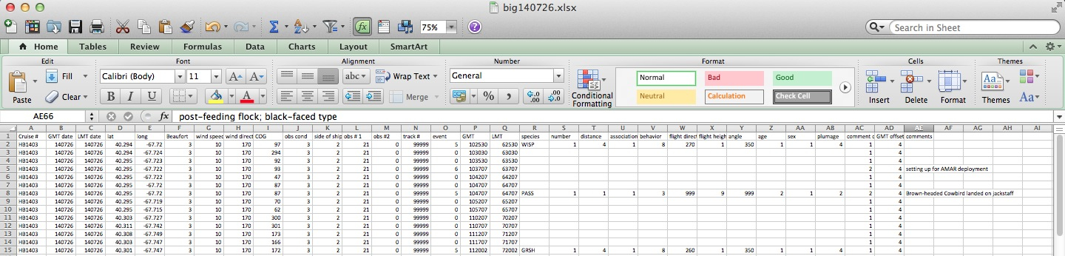

REFERENCES

Anonymous. 2011 Seabird Survey Instruction Protocol. Seabird distribution and abundance, Summer 2011. NOAA RV Henry B. Bigelow. Northeast Fisheries Science Center.

Ballance, Lisa T. 2011. Seabird Survey Instruction Manual, PICEAS 2011. Ecosystems Studies Program Southwest Fisheries Science Center, La Jolla, California.

Bowditch, N. 1966. American Practical Navigator, U.S. Government Printing Office, Hydrographic Office Pub. No. 9, 1524 pages).

Heinemann, D. 1981. A range finder for pelagic bird censusing. Journal of Wildlife Management 45: 489-493.

Tasker, M.L., Hope Jones, P., Dixon, T. and Blake, B.F. 1984. Counting seabirds at sea from
ships; a review of methods employed and a suggestion for a standardized approach. Auk 101: 567 – 577.

